* In the last blog, we have discussed the Errors i.e. Type I Error and Type II Error (α and β), which we have understood by the example of selecting or rejecting a lot. Then we discussed the Power of the Test (1-β) or Iβ. Level of significance α which we ready to tolerate in making the decision, Size of the Test which is numerically equal to the Critical Region which is also known as the Rejection Region in which we saw this region can be one-sided or two-sided. Now,

*Continuing the Concept*…..

* ***One Tailed and Two Tailed Test*** :- If an alternative hypothesis is such that it leads to 2 sided alternatives to the null hypothesis, it is said to be *Two Tailed Test*.

For example, testing

H0 : µ = 20

Vs

H1 : µ ≠ 20

leads to 2 sided test as µ can be greater than 20 or less than 20. In this situation half of the area of critical region lies on the left tail and half on right tail. If α is the area of the critical region, α/2 is the area on both the tails.

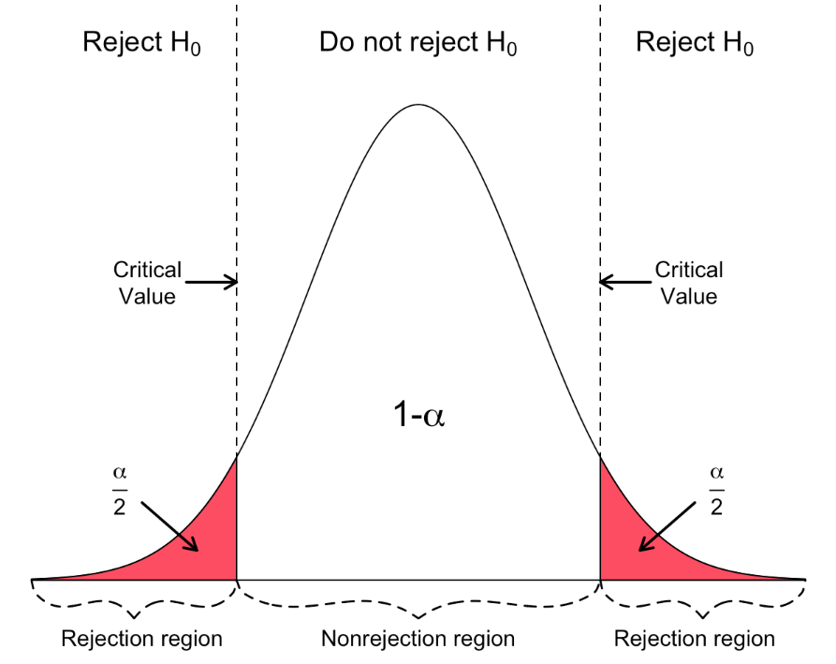

Again, if an alternative hypothesis is such that it leads to 1 sided alternatives to the null hypothesis, it is said to be *One Tailed Test*.

H0 : µ = 20

Vs

H1 : µ < 20 or

H1 : µ > 20

The critical region of size α lies only on one tail. Specifically an area equal to α lies on the right tail given by ω : z > zα  when H1 is µ > 20 and on the left tail when H1 is µ < 20, an area equal to α given by z < -zα.

**Right Tailed**

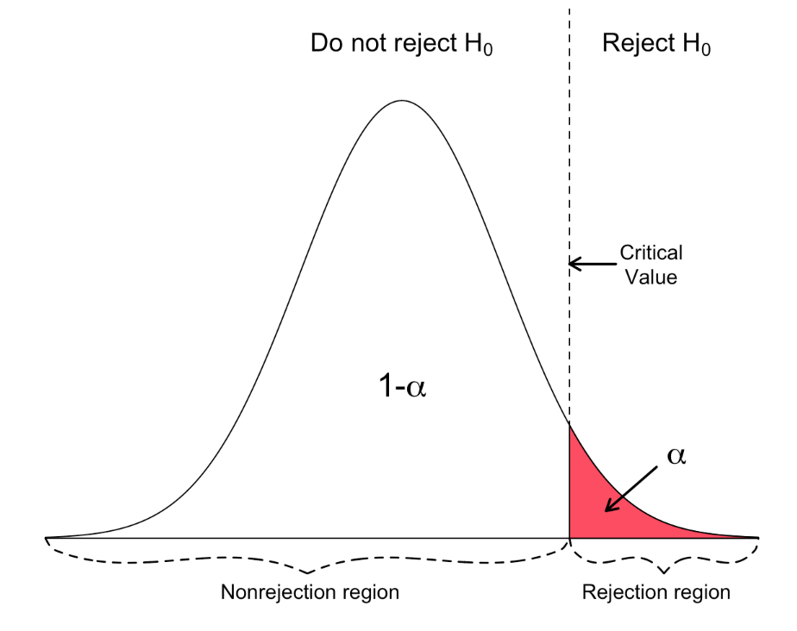

**Left Tailed**

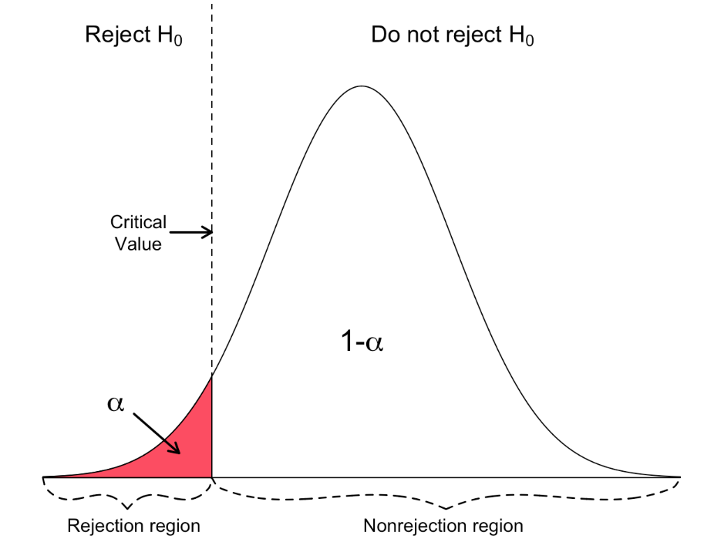

* ***Critical Value or Significant Value*** :- The value of test statistic which separates the critical region (rejection region) and acceptance region is called *Critical or Significant Value*. It depends upon

1. Level of Significance
2. The alternative hypothesis, whether it is two or single tailed.

* ***Non Randomized and Randomized Test*** :- A test *T* of hypothesis *H* is said to be *Non Randomized Test* if the decision about the rejection or acceptance of *H* is based on a test statistic. *H* is rejected if the test statistic lies in the critical region otherwise accepted.

A *Randomized Test* is one in which no test statistics is involved. The decision about *H* is taken on the basis of some predicted criteria. For instance, it is decided that H0 will be accepted if on tossing the coin falls with head and rejected if the coins falls with tail. But *Randomized Tests* are seldom used.

* ***Degrees of Freedom*** :- A test statistic always involves estimate(s) of the parameter(s) under test and estimated values do depend on the sample *vis-a-vis* the sample size. Hence, many observations plays an important role in the testing of hypothesis. Also in a large number of cases, the estimate approaches the true parameter as the sample size increases. In view of these facts it becomes necessary to take into account the sample size while testing a hypothesis.

*The number of independent observations in a set is called Degrees of Freedom (d.f.)*

In other words, degrees of freedom may be defined as the number of observations in a setminus the number of restrictions imposed on them.

* ***Steps of Solving Testing of Hypothesis Problems*** :- The major steps involved in the solution of a *testing of hypothesis* problem may be outlined as follows:

1. Explicit knowledge of the nature of the population distribution and the parameter(s) of interest, i.e. , the parameter(s) about which the hypotheses are set up.
2. Setting up of null hypothesis H0 and the alternative hypothesis H1 in terms of the range of the parameter values each one embodies.
3. The choice of a suitable statistic t called the test statistic, which will best reflect upon the probability of H0 and H1.
4. Partitioning the set of possible values of the test statistic *t* into two disjoint sets C (critical region or rejection region) and C’ (acceptance region) and framing the following test:
5. Reject H0 if the value the value of *t* falls in C.
6. Accept H0 if the value of *t* falls in C’.
7. After framing the above tests, obtain experimental sample observations, compute the appropriate test statistic and take action accordingly.

* ***Optimum Test*** :- A test is said to be optimum if it minimizes both the errors α and β. Unfortunately, no such test is available as the reduction in one type of error causes the increase in the other. Hence, in normal practice a test which minimizes β or maximizes (1-β) for a desired low level of α is considered to be an *Optimum Test* or Best Test.

For comparing different tests of a hypothesis H, it becomes necessary to look into the properties of the tests. Main properties of the statistical non-randomized tests are as follows:

* 1. Most Powerful (MP)
  2. Uniformly Most Powerful (UMP)
  3. Unbiased
  4. Uniformly Most powerful Unbiased (UMPU)
  5. Minimax
  6. Admissible